Table of contents
CONTENTS | PAGE NO
ABSTRACT | i
LIST OF FIGURES | ii
LIST OF TABLES | iii
ACRONYMS | iv
1. INTRODUCTION | 1
1.1 Brief Information about the Project | 1
1.2 Motivation and Contribution of Project | 1
1.3 Objectives of the Project | 2
1.4 Scope of the Project | 2
2. SYSTEM ANALYSIS | 3
2.1 Functional Requirements | 3
2.2 Non-Functional Requirements | 4
2.3 Requirements Specification | 4
2.3.1 Minimum Hardware Requirements | 4
2.3.2 Software Requirements | 4
3. TECHNOLOGY DESCRIPTION | 5
3.1 Programming Language | 5
3.1.1 Introduction to Java | 5
3.2 Framework / Libraries | 5
3.2.1 Introduction to Swing | 5
3.3 Database Technology | 5
3.3.1 JDBC (Java Database Connectivity) | 6
3.3.2 MySQL Database | 6
3.4 Tools & IDEs | 6
3.4.1 Visual Studio Code | 6
4. DATABASE DESIGN | 7
4.1 Database Tables | 7
4.2 Table Structure | 7
4.3 Keys and Constraints | 8
4.4 Table Relationships | 8
5. SYSTEM DESIGN | 9
5.1 System Architecture | 9
5.2 Modules Description | 9
6. SYSTEM IMPLEMENTATION | 10
7. CONCLUSION | 12
8. FUTURE ENHANCEMENTS | 13
9. REFERENCES | 14
APPENDIX (Sample Code) | 15
APPENDIX (SQL Queries) | 16

ABSTRACT

The Online Shopping Cart (OCS) is a desktop-based Java application designed to simulate a complete e-commerce shopping experience. It enables users to register, log in, browse available products, add items to their cart, and place orders through a structured and secure workflow. An admin module allows product management and system oversight, including adding new products, updating existing product details, and removing products from the catalogue. Developed using Core Java for application logic, Java Swing for the graphical user interface, JDBC for database connectivity, and MySQL as the backend database, the system ensures data integrity, reduces manual effort, and improves accessibility. With its user-friendly interface and efficient data handling, the application demonstrates a complete end-to-end shopping workflow suitable for academic and small-scale business use.

LIST OF FIGURES

Figure No. | Figure Title | Page No.
1 | Login Screen of Online Shopping Cart | 10
2 | User Registration Screen | 10
3 | Admin Login Screen | 10
4 | Admin Product Management Screen | 10
5 | Product Listing Screen | 11
6 | Add to Cart Screen | 11
7 | Cart View Screen | 11
8 | Order Summary Screen | 11

LIST OF TABLES

Table No. | Table Title | Page No.
1 | Products Relational Database Table | 7
2 | Users Relational Database Table | 7
3 | Cart Relational Database Table | 8
4 | Orders Relational Database Table | 8
5 | Admin Relational Database Table | 8

ACRONYMS

- OCS : Online Shopping Cart
- JDBC : Java Database Connectivity
- GUI : Graphical User Interface
- SQL : Structured Query Language
- DBMS : Database Management System
- IDE : Integrated Development Environment
- API : Application Programming Interface
- JVM : Java Virtual Machine

1. INTRODUCTION
1.1 Brief Information about the Project
The Online Shopping Cart (OCS) is a desktop-based Java application that provides users with a simulated e-commerce experience. It enables customers to register, log in, browse products, add items to a cart, and confirm orders through a structured interface. An administration module allows the admin to manage product listings and oversee system data. The system replaces paper-based or spreadsheet-driven order tracking with a relational database solution, improving data accuracy, consistency, and retrieval speed. The application is developed using Core Java, Java Swing, JDBC, and MySQL Database, making it suitable for academic demonstrations and small-scale retail scenarios.
1.2 Motivation and Contribution of Project
Traditional shopping management in small businesses often relies on manual records or disconnected spreadsheet tools, which leads to data duplication, inventory inaccuracies, and poor order tracking. The Online Shopping Cart system was motivated by the need to demonstrate how these challenges can be overcome with a structured, database-driven desktop application.
The key contributions of this project include:
- Providing a complete digital workflow from product browsing to order placement
- Implementing user authentication for customers and administrators separately
- Maintaining a live cart linked to user accounts for session-based shopping
- Storing order history with timestamps for traceability
- Demonstrating relational database design with cascading foreign key constraints
1.3 Objectives of the Project
The main objectives of the Online Shopping Cart are:
- To develop a user-friendly desktop application for simulating online shopping
- To implement secure login and registration for both users and admin
- To allow users to browse products, manage a cart, and place orders
- To enable the admin to add, update, and manage product listings
- To store all data reliably in a MySQL relational database using JDBC
- To demonstrate referential integrity through proper foreign key relationships
1.4 Scope of the Project
The Online Shopping Cart system can be deployed in academic labs, small retail demonstrations, or as a foundation for a larger e-commerce application. The system supports user registration and login, product browsing, cart management, order placement, and admin-level product control. The application is designed for single-machine use with a local MySQL database but can be extended to support multi-user network access. The scope is limited to core shopping cart functionality; payment gateway integration and delivery tracking are outside the current scope but may be added in future enhancements.

2. SYSTEM ANALYSIS
2.1 Functional Requirements
Functional requirements define the core operations that the Online Shopping Cart (OCS) must perform to serve its users effectively. The Functional requirements of Online Shopping Cart (OCS) are:
• User Registration and Login
The system should allow new customers to register with a unique username and password. Registered users and the admin must be authenticated before accessing the system.
• Product Browsing
The system should display available products with their names and prices. Users should be able to view the product catalogue before adding items to the cart.
• Add to Cart
Authenticated users should be able to select one or more products and add them to their personal cart with a defined quantity.
• View and Manage Cart
Users should be able to view all items currently in their cart, update quantities, or remove items before proceeding to checkout.
• Place Order
The system should allow users to confirm their cart and place an order. The total amount shall be calculated automatically and an order record shall be saved with a timestamp.
• Admin Product Management
The admin should be able to add new products, update existing product details, and remove products from the catalogue. The admin module is accessible through a dedicated admin login separate from the user login.
2.2 Non-Functional Requirements
Non-functional requirements define the quality attributes the system must satisfy.
• Performance The system should respond to search, add, and update operations without noticeable delay.
The system should respond to search, add, and update operations without noticeable delay.
• Security
User and admin credentials must be validated before granting access. Password data is stored in the database.
• Usability
The interface should be simple, intuitive, and require minimal training to operate.
• Reliability
The system should handle invalid inputs gracefully and avoid data corruption or loss.
• Scalability
The database schema supports additional tables and features without structural redesign.
2.3 Requirements Specification
This section specifies the minimum hardware and software needed to run the system.
2.3.1 Minimum Hardware Requirements
- Processor: Intel Core i3 or equivalent and above
- RAM: 4 GB (minimum)
- Hard Disk: 20 GB free space
- Monitor: Standard display (1024 × 768 or higher)
- Keyboard and Mouse
2.3.2 Software Requirements
- Operating System: Windows 7 / 10 / 11
- Programming Language: Java (JDK 8 or above)
- IDE: Visual Studio Code (with Java Extension Pack)
- Database: MySQL Server 5.7 or above
- Database Connectivity: JDBC (MySQL Connector/J)

3. TECHNOLOGY DESCRIPTION
3.1 Programming Language
3.1.1 Introduction to Java
Java is a high-level, object-oriented, platform-independent programming language developed by Sun Microsystems (now Oracle). It is widely used for desktop, web, and enterprise application development due to its robustness, security, and portability.
In the Online Shopping Cart project, Java is used to implement all core functionality, including user authentication, cart management, order processing, and database interaction. Java's strong exception-handling and memory management features ensure the application remains stable and reliable during operation.
A key advantage of Java is its platform independence: code compiled to bytecode can run on any machine with a Java Virtual Machine (JVM), making the application portable across different operating systems.
3.2 Framework / Libraries
3.2.1 Introduction to Swing
Java Swing is a GUI toolkit included in the Java Foundation Classes (JFC). It provides a rich set of lightweight components — buttons, labels, text fields, combo boxes, tables, and scroll panes — that enable the creation of interactive desktop interfaces.
In this project, Swing is used to build all screens of the Online Shopping Cart, including:
- Login and Registration Screens
- Admin Login and Product Management Screen
- Product Listing Screen
- Add to Cart Screen
- Cart View and Checkout Screen
Swing's layout managers provide flexibility in positioning components, while its event-handling model allows seamless response to user interactions.
3.3 Database Technology
The Online Shopping Cart uses a relational database to store and manage all persistent data — products, users, carts, orders, and admin credentials — in a structured and consistent manner. MySQL is used as the database engine, and JDBC serves as the connectivity layer.
3.3.1 JDBC (Java Database Connectivity)
JDBC is an API (Application Programming Interface) used in Java to connect and interact with databases. It allows Java applications to execute SQL queries and retrieve or update data in the database.
In the Online Shopping Cart, JDBC is used to:
- Establish a connection to the MySQL shopping_cart database
- Execute INSERT, UPDATE, DELETE, and SELECT SQL statements
- Retrieve query results and display them in the GUI
- Close database connections to free resources
JDBC acts as a bridge between the application layer and the MySQL backend, ensuring smooth and reliable data exchange.
3.3.2 MySQL Database
MySQL is a widely-used open-source relational database management system. It offers high performance, reliability, and ease of use for managing structured data with SQL.
In this project, MySQL stores all application data including product listings, registered user credentials, cart items, admin credentials, and completed orders. It enforces data integrity through primary keys, foreign keys, and NOT NULL constraints, ensuring consistency across related tables.
3.4 Tools & IDEs
3.4.1 Visual Studio Code
Visual Studio Code (VS Code) is a lightweight, extensible code editor developed by Microsoft. With the Java Extension Pack installed, VS Code provides full Java development support including syntax highlighting, IntelliSense code completion, integrated debugging, and terminal access.
VS Code is used as the primary development environment for the Online Shopping Cart project. Its integrated terminal simplifies running Java programs and MySQL queries during development and testing.

4. DATABASE DESIGN
4.1 Database Tables
The Online Shopping Cart system uses a MySQL database named shopping_cart. The database consists of five tables: products, users, admin, cart, and orders.
- products : Stores all available product listings
- users : Stores registered customer credentials
- admin : Stores administrator login credentials
- cart : Stores items added to cart by each user, linked to products and users
- orders : Records confirmed orders with total amount and order timestamp
4.2 Table Structure
4.2.1 Products Table
Field Name | Data Type | Description | Constraint
product_id | INT | Product ID | Primary Key / Auto Increment
name | VARCHAR(50) | Product Name | Not Null
price | DOUBLE | Product Price | Not Null

Table 1: Products Relational Database Table
4.2.2 Users Table
Field Name | Data Type | Description | Constraint
user_id | INT | User ID | Primary Key / Auto Increment
username | VARCHAR(50) | User Name | Not Null
password | VARCHAR(50) | User Password | Not Null

Table 2: Users Relational Database Table
4.2.3 Cart Table
Field Name | Data Type | Description | Constraint
cart_id | INT | Cart ID | Primary Key / Auto Increment
product_id | INT | Product Reference | Foreign Key
user_id | INT | User Reference | Foreign Key
quantity | INT | Item Quantity | Default: 1

Table 3: Cart Relational Database Table
4.2.4 Orders Table
Field Name | Data Type | Description | Constraint
order_id | INT | Order ID | Primary Key / Auto Increment
user_id | INT | User Reference | Foreign Key
total_amount | DOUBLE | Total Order Amount | Not Null
order_date | TIMESTAMP | Date of Order | Default: CURRENT_TIMESTAMP

Table 4: Orders Relational Database Table
4.2.5 Admin Table
Field Name | Data Type | Description | Constraint
admin_id | INT | Admin ID | Primary Key / Auto Increment
username | VARCHAR(50) | Admin Username | Not Null
password | VARCHAR(50) | Admin Password | Not Null

Table 5: Admin Relational Database Table
4.3 Keys and Constraints
Keys and constraints are used to maintain data integrity across all tables.
• Primary Keys:
- product_id in the products table
- user_id in the users table
- cart_id in the cart table
- order_id in the orders table
- admin_id in the admin table
• Foreign Keys:
- product_id in cart references products(product_id) — ON DELETE CASCADE
- user_id in cart references users(user_id) — ON DELETE CASCADE
- user_id in orders references users(user_id) — ON DELETE CASCADE
• NOT NULL Constraints:
- name, price in products; username, password in users and admin; total_amount in orders
• Default Values:
- quantity in cart defaults to 1; order_date in orders defaults to CURRENT_TIMESTAMP
4.4 Table Relationships
The tables are related as follows:
- Each cart item belongs to one product and one user — many-to-one relationships with ON DELETE CASCADE
- Each order belongs to one user — many-to-one relationship with ON DELETE CASCADE
- admin is an independent table with no foreign key relationships
The cascading delete ensures that if a user or product is removed, all associated cart items are automatically cleaned up, maintaining referential integrity across the database.

5. SYSTEM DESIGN
5.1 System Architecture
The Online Shopping Cart follows a three-layer architecture:
- Presentation Layer (User Interface)
- Developed using Java Swing
- Provides all interactive screens for users and admin
- Application Layer (Business Logic)
- Processes user inputs and validates operations
- Handles cart calculations and order totals
- Data Layer (Database)
- MySQL database stores all persistent data
- JDBC connects the application layer to the database
This architecture ensures separation of concerns, easier maintenance, and improved data security.
5.2 Modules Description
The system is divided into the following modules:
1. User Module
- Handles user registration, login, product browsing, cart management, and order placement
2. Admin Module
- Handles admin login through a dedicated admin login screen
- Allows admin to add new products to the catalogue
- Allows admin to update existing product name and price
- Allows admin to delete products from the system
- Admin has full control over the product database
3. Cart Module
- Manages cart items — linking products to users, tracking quantities, and supporting removal
4. Order Module
- Confirms cart contents as an order, calculates total, stores order with timestamp
5. Database Connectivity Module
- Establishes JDBC connection to MySQL and executes all SQL operations
6. User Interface Module
- All Swing-based screens that present information and capture user input

6. SYSTEM IMPLEMENTATION
Login Screen:
Displays the login interface where the user or admin enters their username and password to access the system.
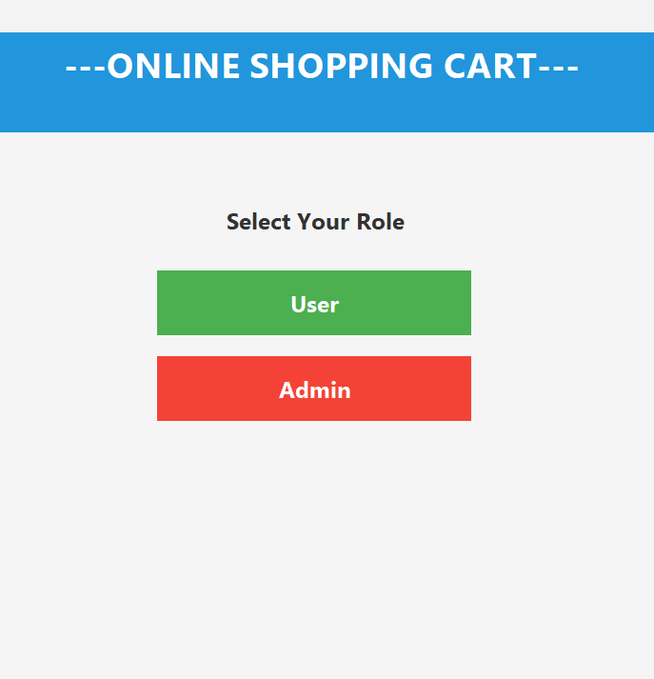
Figure 1: Login Screen of Online Shopping Cart

User Registration Screen:
Displays the registration form where new users enter a username and password to create an account.

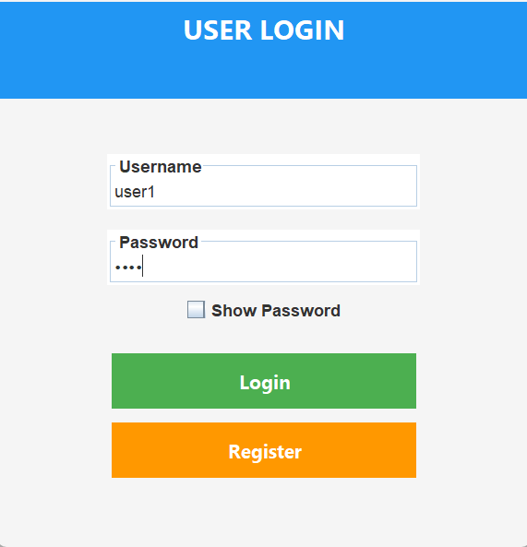

Admin Login Screen:
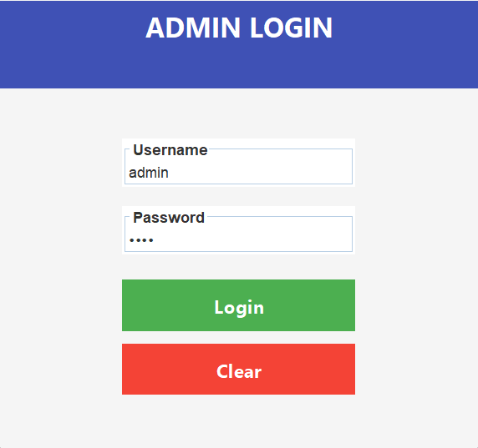

Displays a dedicated admin login interface. The admin enters credentials to access the admin panel, which is separate from the user login flow.
Figure 3: Admin Login Screen

Admin Product Management Screen:
Shows the admin panel where the administrator can add new products, update existing product details (name and price), and delete products from the system. All changes are immediately reflected in the database and visible to users.

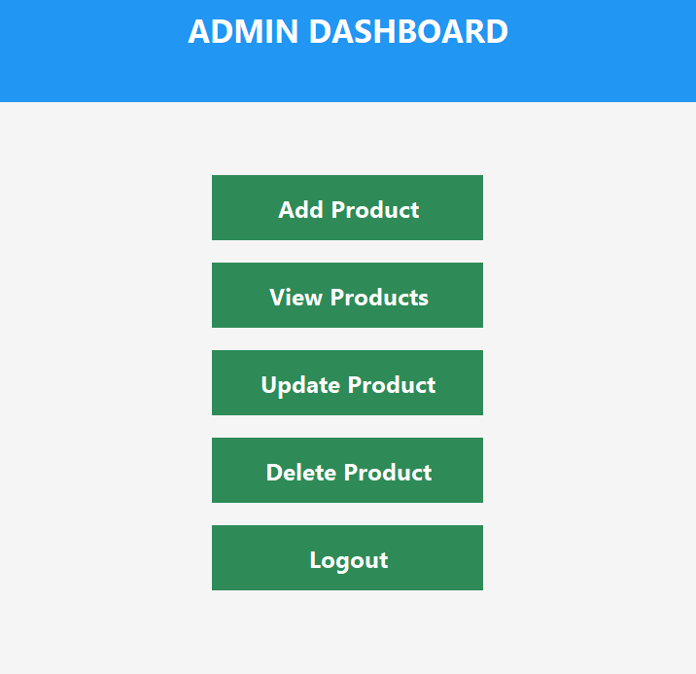

Product Listing Screen:
Shows all available products with their names and prices. Users can select items to add to their cart.
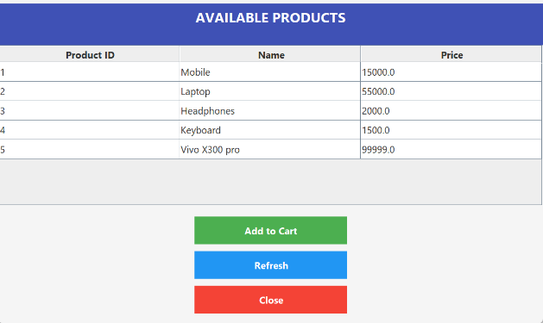

Add to Cart Screen:
Allows users to select a product, specify quantity, and confirm adding the item to their cart.

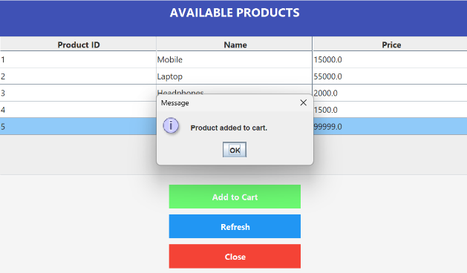

Cart View Screen:
Displays all items currently in the user's cart with product names, quantities, and individual prices.

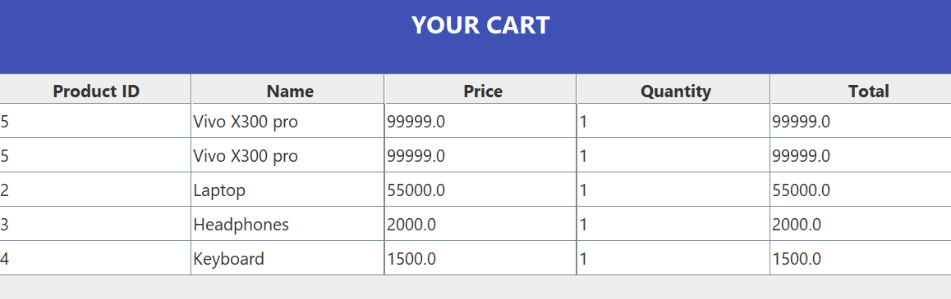

Order Summary Screen:
Shows a summary of the confirmed order including total amount and order date after successful checkout.
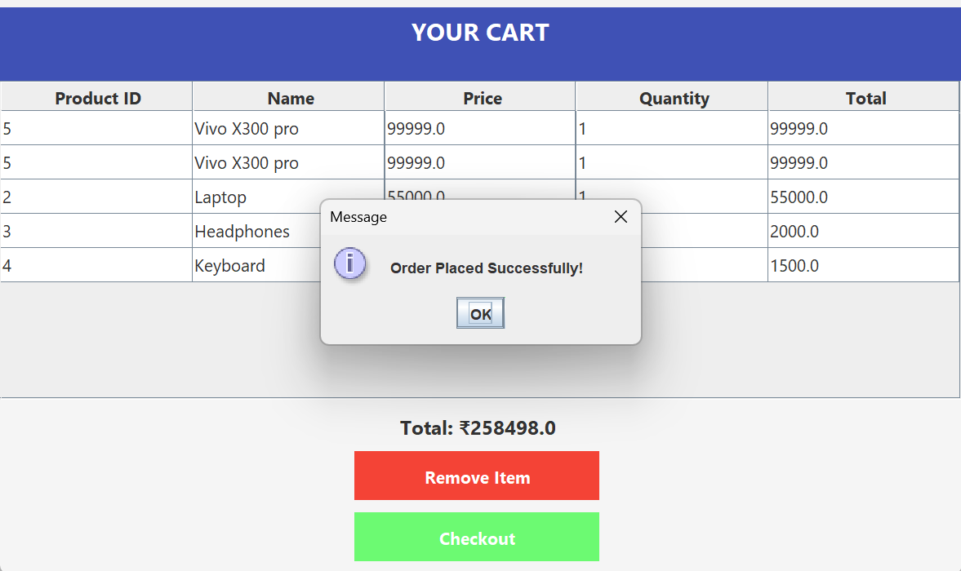
Figure 8: Order Summary Screen

7. CONCLUSION
The Online Shopping Cart has been successfully developed as a desktop-based Java application that simulates a complete e-commerce workflow. The system replaces manual product and order tracking with a reliable, database-driven solution, improving data consistency, speed, and accessibility.
The application delivers all planned functionalities: user registration and login, product browsing, cart management, order placement, and admin-level product control. The admin module, accessed via a dedicated login screen, enables the administrator to manage the product catalogue independently from the user-facing shopping experience. By using Java, Swing, JDBC, and MySQL, the system ensures stable performance, data integrity through relational constraints, and a user-friendly experience.
The project successfully demonstrates the practical application of object-oriented programming, GUI development, and relational database design. It meets all stated objectives and provides a scalable foundation that can be extended with additional features such as payment integration, order history views, and web-based access.
Overall, the Online Shopping Cart meets the project goals and serves as an effective demonstration of a full-stack desktop application built with Java technologies.

8. FUTURE ENHANCEMENTS
The current implementation of the Online Shopping Cart covers core shopping functionality. The following enhancements can be implemented to extend the system in future iterations:
• Payment Gateway Integration:
Adding support for payment methods such as UPI, credit/debit card, or net banking to simulate real-world checkout.
• Order History and Invoice Generation:
Enabling users to view past orders and download PDF invoices for each completed purchase.
• Product Search and Filtering:
Implementing keyword search, category filtering, and price range filtering for faster product discovery.
• Web-Based Application:
Migrating the desktop application to a web-based platform using Java Servlets, JSP, or Spring Boot for remote accessibility.
• Role-Based Access Control:
Expanding the authentication system to support multiple admin roles with different permission levels.
• Stock / Inventory Management:
Adding a stock quantity field to products so that the system can track availability and prevent overselling.
• Improved User Interface:
Redesigning the GUI with modern themes, responsive layouts, and improved visual feedback for user interactions.

9. REFERENCES
The following references were used during the development of the Online Shopping Cart:

- Herbert Schildt, Java: The Complete Reference, Oracle Press, 11th Edition.
- E. Balagurusamy, Programming with Java, McGraw Hill Education.
- Korth, Silberschatz, Sudarshan, Database System Concepts, McGraw Hill.
- MySQL Documentation, https://dev.mysql.com/doc/
- Java Documentation (Oracle), https://docs.oracle.com/javase
- JDBC Tutorial — GeeksforGeeks, https://www.geeksforgeeks.org/jdbc/
- Java Swing Tutorial — TutorialsPoint, https://www.tutorialspoint.com/java_swing
- W3Schools Java Tutorial, https://www.w3schools.com/java/

APPENDIX
A.1 Sample Code
Database Connection Code:
The following code establishes a connection between the Java application and the MySQL database using JDBC.
DBConnection.java:
import java.sql.*;
public class DBConnection {
public static Connection getConnection() {
Connection con = null;
try {
Class.forName("com.mysql.cj.jdbc.Driver");
con = DriverManager.getConnection(
"jdbc:mysql://localhost:3306/shopping_cart", "root", "password");
} catch (Exception e) {
System.out.println(e);
}
return con;
}
}

Add Product to Cart:
This code inserts a selected product into the cart for the currently logged-in user.
AddToCart.java:
import java.sql.*;
public class AddToCart {
public static void addItem(int productId, int userId, int quantity) {
try {
Connection con = DBConnection.getConnection();
String query = "INSERT INTO cart (product_id, user_id, quantity) VALUES (?,?,?)";
PreparedStatement pst = con.prepareStatement(query);
pst.setInt(1, productId);
pst.setInt(2, userId);
pst.setInt(3, quantity);
int i = pst.executeUpdate();
if (i > 0) System.out.println("Item added to cart.");
con.close();
} catch (Exception e) {
System.out.println(e);
}
}
}

Admin: Add Product:
This code allows the admin to insert a new product into the products table.
AddProduct.java:
import java.sql.*;
public class AddProduct {
public static void addProduct(String name, double price) {
try {
Connection con = DBConnection.getConnection();
String query = "INSERT INTO products (name, price) VALUES (?, ?)";
PreparedStatement pst = con.prepareStatement(query);
pst.setString(1, name);
pst.setDouble(2, price);
int i = pst.executeUpdate();
if (i > 0) System.out.println("Product added successfully.");
con.close();
} catch (Exception e) {
System.out.println(e);
}
}
}

A.2 SQL Queries
Database Setup:
CREATE DATABASE IF NOT EXISTS shopping_cart;
USE shopping_cart;

Create Products Table:
CREATE TABLE IF NOT EXISTS products (
product_id INT AUTO_INCREMENT PRIMARY KEY,
name VARCHAR(50) NOT NULL,
price DOUBLE NOT NULL
);

Create Users Table:
CREATE TABLE IF NOT EXISTS users (
user_id INT AUTO_INCREMENT PRIMARY KEY,
username VARCHAR(50) NOT NULL,
password VARCHAR(50) NOT NULL
);

Create Admin Table:
CREATE TABLE IF NOT EXISTS admin (
admin_id INT AUTO_INCREMENT PRIMARY KEY,
username VARCHAR(50) NOT NULL,
password VARCHAR(50) NOT NULL
);

Create Cart Table:
CREATE TABLE IF NOT EXISTS cart (
cart_id INT AUTO_INCREMENT PRIMARY KEY,
product_id INT,
user_id INT,
quantity INT DEFAULT 1,
FOREIGN KEY (product_id) REFERENCES products(product_id) ON DELETE CASCADE,
FOREIGN KEY (user_id) REFERENCES users(user_id) ON DELETE CASCADE
);

Create Orders Table:
CREATE TABLE IF NOT EXISTS orders (
order_id INT AUTO_INCREMENT PRIMARY KEY,
user_id INT,
total_amount DOUBLE NOT NULL,
order_date TIMESTAMP DEFAULT CURRENT_TIMESTAMP,
FOREIGN KEY (user_id) REFERENCES users(user_id) ON DELETE CASCADE
);

Insert Sample Data:
INSERT INTO products (name, price) VALUES
('Mobile', 15000), ('Laptop', 55000),
('Headphones', 2000), ('Keyboard', 1500);

INSERT INTO users (username, password) VALUES
('user1', '1234'), ('user2', 'abcd');

INSERT INTO admin (username, password) VALUES ('admin', '1234');

